Experiment No-05
Study of CMOS NOR Gate Schematics in Cadence Virtuoso Software
1.1 Objectives
The main objectives of this experiment are summarized as:
- To understand the concept and operation of a two-input CMOS NOR gate as a fundamental building block of digital logic circuits.
- To become familiar with the Cadence Virtuoso schematic editor and the standard IC design flow used to create standard cells.
- To design the transistor-level schematic of a two-input CMOS NOR gate, using two series PMOS transistors as the pull-up network and two parallel NMOS transistors as the pull-down network from the gpdk090 technology library, and to generate its schematic symbol.
- To construct a test bench for the NOR gate, with two independent pulse sources at its two inputs, and verify its functionality through transient simulation using Spectre in the Analog Design Environment (ADE L).
- To obtain and analyze the transient input/output wave-forms of the designed NOR gate for all combinations of its two input signals, and to verify them against the NOR truth table.
Keywords- CMOS NOR gate, NMOS, PMOS, Cadence Virtuoso, schematic editor, Spectre, transient response, truth table, standard cell.
1.2 Theory
A NOR gate is a fundamental digital logic gate whose output is the complement of the logical OR of its inputs. For a two-input NOR gate with inputs A and B and output Y, the operation is expressed by the Boolean expression Y = (A + B)′. The output is HIGH (logic 1) only when both inputs are LOW (logic 0); for every other combination of inputs, the output is LOW (logic 0). The truth table of an ideal two-input NOR gate is shown in Table-1.1.
A | B | Y = (A + B)′
0 | 0 | 1
0 | 1 | 0
1 | 0 | 0
1 | 1 | 0
Table-1.1. Truth table of an ideal two-input NOR gate.
1.2.1 The CMOS NOR Gate
A Complementary Metal-Oxide-Semiconductor (CMOS) NOR gate implements the NOR function using two complementary networks of transistors: a pull-up network of two PMOS transistors connected in series between the supply voltage VDD and the output node, and a pull-down network of two NMOS transistors connected in parallel between the output node and ground, VSS. The two inputs, A and B, are each connected to the gate of one PMOS transistor and one NMOS transistor, and the drain of the lower PMOS device and the drains of the two NMOS devices are tied together to form the single output terminal.
The output node is pulled up to VDD only when both series PMOS transistors are simultaneously ON, which occurs only when both A and B are LOW; if either input is HIGH, at least one of the parallel NMOS transistors is ON and pulls the output down to ground, while the corresponding PMOS transistor is OFF and breaks the pull-up path. Because the pull-up and pull-down networks are never both fully ON at the same time for any static input combination, there is no direct conduction path from VDD to ground, and the static power dissipation of the CMOS NOR gate is ideally zero; power is dissipated mainly during switching (dynamic power) and due to leakage currents in real devices.
1.2.2 Transistor Sizing and the Effect of PMOS Stacking
Unlike a single-input inverter, the pull-up network of a two-input NOR gate consists of two PMOS transistors connected in series (a transistor “stack”). Because the two series devices carry the same current, the effective ON-resistance of the pull-up network is higher than that of a single PMOS transistor of the same width, which tends to slow the rising (LOW-to-HIGH) transition of the output relative to the falling transition. Since the stack is made of PMOS devices, which are already the weaker devices for a given width, this effect is more pronounced than the NMOS stacking in a NAND gate.
Because the mobility of holes in a PMOS transistor is lower than the mobility of electrons in an NMOS transistor, a PMOS device must be made wider than an NMOS device of the same length to provide comparable drive strength. In this experiment, the same transistor dimensions used for the earlier CMOS inverter design were retained for the NOR gate: each PMOS device was sized with a total width of 720 nm, and each NMOS device with a total width of 240 nm, for the same channel length of 100 nm, giving the same 3:1 PMOS-to-NMOS width ratio as before. Keeping these dimensions unchanged preserves consistency with the earlier experiments, although the series PMOS stack means the pull-up network is comparatively weaker here than it was for the single-transistor inverter.
1.2.3 Cadence Virtuoso Design Flow
In this experiment, the CMOS NOR gate is designed and verified using the Cadence Virtuoso IC design environment. The overall flow consists of creating a design library attached to a process technology library (gpdk090), drawing the transistor-level schematic in the Schematic XL editor by placing and sizing two PMOS and two NMOS instances and wiring them into the series pull-up / parallel pull-down NOR topology, generating a schematic symbol for the NOR cell, and finally building a separate test bench schematic in which the NOR symbol is instantiated along with two independent input sources and supply sources. The test bench is then simulated using the Spectre simulator inside the Analog Design Environment (ADE L) to verify the NOR gate’s transient behaviour.
1.3 Hardware/Software Used for the Experiment
1. Cadence Virtuoso Schematic Editor (Schematic XL)
2. Virtuoso Analog Design Environment (ADE L)
3. Spectre circuit simulator
4. gpdk090 generic process design kit (technology library)
5. Two NMOS and two PMOS transistors (gpdk090_nmos1v, gpdk090_pmos1v)
6. Two pulse voltage sources (vpulse), a DC voltage source (vdc) and ground (gnd) from analogLib
7. Linux workstation running the Cadence design environment
1.4 Experimental and Simulation Analysis
A design library (NOR_Gate) was created and attached to the gpdk090 technology library, and a schematic cellview (carried over from the earlier inverter template and therefore still internally named inverter) was modified within it to implement the two-input NOR function. Two NMOS and two PMOS instances were placed in the schematic, sized as described in Section 1.2.2, and wired into the series PMOS pull-up network and parallel NMOS pull-down network, with two input pins (VinA and VinB), an output pin (Vout), and the VDD/VSS supply pins. A schematic symbol was then generated for the NOR cell. A separate test schematic (inverter_test) was built in which the NOR symbol was instantiated with two independent pulse sources at its two inputs and a DC supply and ground connected to its power pins, and the design was simulated in ADE L using the Spectre simulator. Each of these steps is illustrated below.
1.4.1 Transistor Sizing and Parameter Selection
The width and length of each transistor were set in the Add Instance window at the time of placement. As in the earlier inverter design, each NMOS transistor (NM0, NM1) was sized with a total width of 240 nm and a channel length of 100 nm, while each PMOS transistor (PM0, PM1) was sized with a total width of 720 nm and the same channel length of 100 nm, giving the 3:1 PMOS-to-NMOS width ratio discussed in Section 1.2.2. The parameter selection window used for setting the NMOS device dimensions is shown in Figure-1.1.
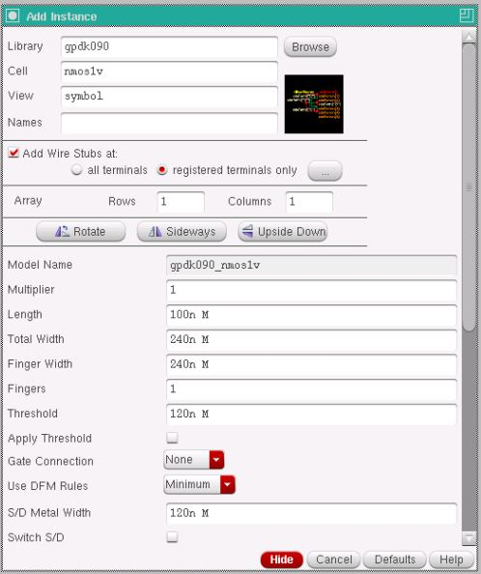
Figure-1.1. Add Instance window showing the width and length parameters set for the NMOS transistor (Total Width = 240n, Length = 100n).
Device | Width (W) | Length (L)
NMOS – NM0, NM1 (gpdk090_nmos1v) | 240 nm | 100 nm
PMOS – PM0, PM1 (gpdk090_pmos1v) | 720 nm | 100 nm
Table-1.2. Device parameters used for the NMOS and PMOS transistors in the NOR gate schematic.
1.4.2 Transistor-Level Schematic of the CMOS NOR Gate
The two PMOS transistors (PM0, PM1) were connected in series between the VDD pin and the output node, with the source of PM0 connected to VDD and the drain of PM1 connected to the output node, while the two NMOS transistors (NM0, NM1) were connected in parallel between the output node and the VSS pin. The gates of PM0 and NM0 were tied together to form input A (VinA), and the gates of PM1 and NM1 were tied together to form input B (VinB). The output node was connected to the output pin Vout (labelled Output in the schematic). The complete transistor-level schematic of the CMOS NOR gate, with all pins and wires labelled, is shown in Figure-1.2.
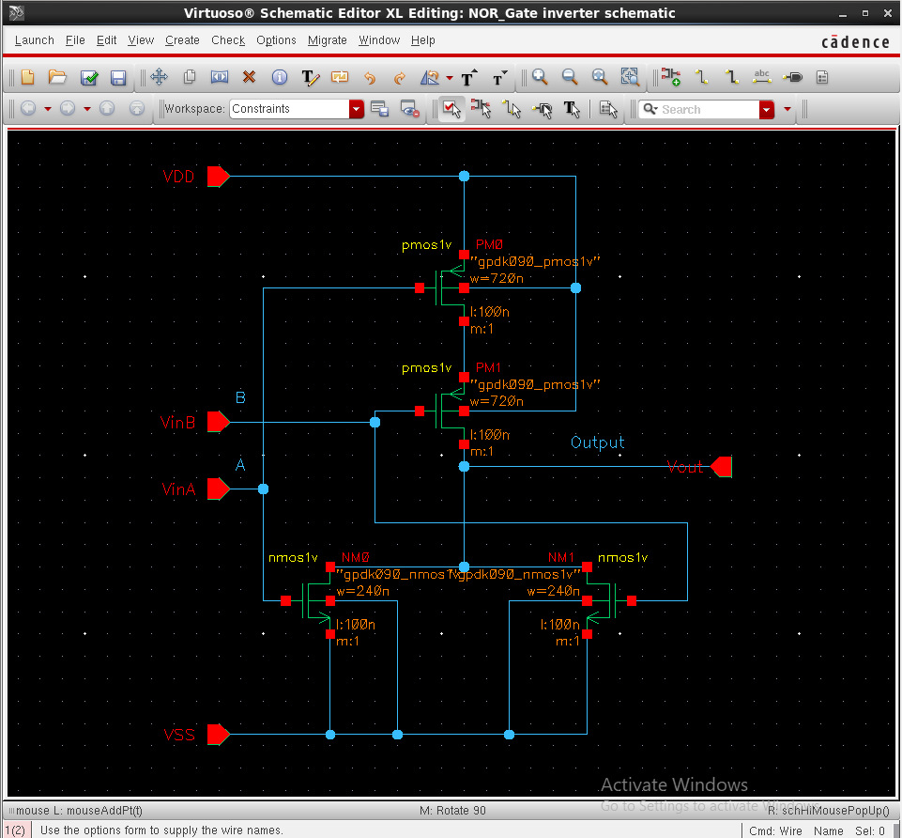
Figure-1.2. Complete transistor-level schematic of the CMOS NOR gate, showing the two series PMOS transistors (PM0, PM1) forming the pull-up network, the two parallel NMOS transistors (NM0, NM1) forming the pull-down network, and the VinA, VinB, Vout, VDD and VSS pins.
1.4.3 Schematic Symbol Generation
After the schematic was checked and saved without errors, a schematic symbol was generated from the cellview using Create → Cellview → From Cellview, with VinA and VinB placed as the two left-side input pins, Vout placed as the right-side output pin, and VDD and VSS placed as the top and bottom pins. The default shape generated by Virtuoso was replaced with the conventional two-input NOR symbol, a curved OR-gate body with an output bubble (distinguishing it from the OR symbol), with the label NOR placed at its centre, as shown in Figure-1.3.
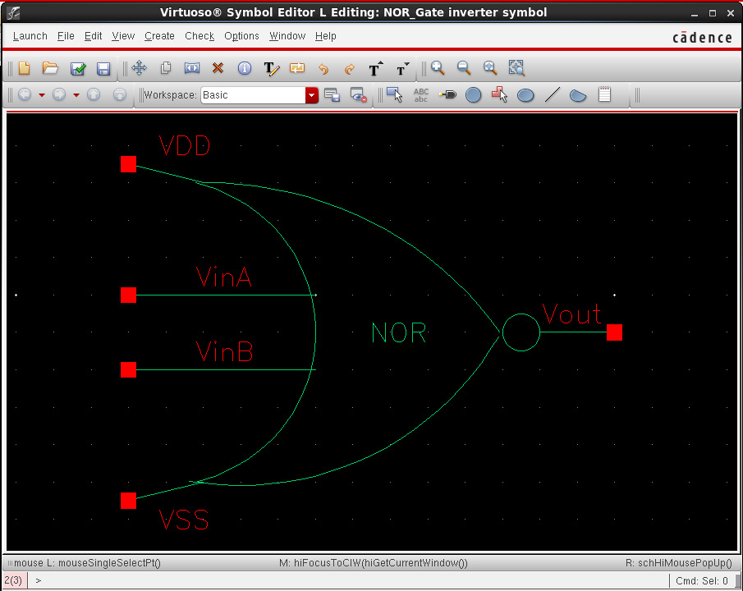
Figure-1.3. Generated schematic symbol of the CMOS NOR gate, showing the two inputs VinA and VinB, the output Vout, and the VDD and VSS supply pins.
1.4.4 Test Bench Construction and Source Addition
A separate schematic, inverter_test, was created to verify the NOR gate. The generated NOR symbol was instantiated, and two independent pulse voltage sources (vpulse) from analogLib were connected to its two inputs: source V1 was connected to input A (VinA) with voltage1 = 0 V, voltage2 = 1.8 V, period = 20 ns and pulse width = 10 ns, while source V2 was connected to input B (VinB) with voltage1 = 0 V, voltage2 = 1.8 V, period = 40 ns and pulse width = 20 ns, so that all four input combinations of A and B are exercised over the course of the simulation. A DC voltage source (vdc) set to 1.8 V and a ground (gnd) were connected to the VDD and VSS pins respectively, and the input and output nets were named A, B and Output using Create → Wire Name. The completed test bench, with all sources added, is shown in Figure-1.4.
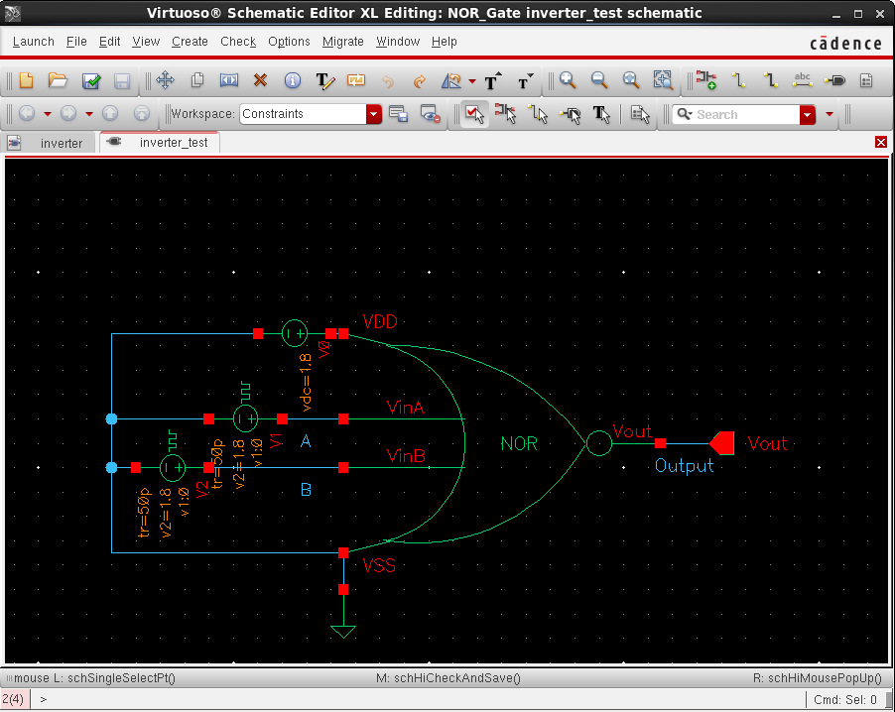
Figure-1.4. Test bench schematic (inverter_test) with the two pulse input sources V1 and V2, the DC supply V0, ground, and the NOR symbol, with the A, B and Output nets labelled.
1.4.5 Input Source Parameter Selection
The Add Instance windows used to configure the two pulse sources and the DC supply are shown in Figure-1.5, Figure-1.6 and Figure-1.7. Figure-1.5 shows the parameters of source V1 driving input A, with Voltage 1 = 0 V, Voltage 2 = 1.8 V, a period of 20 ns, a pulse width of 10 ns, and rise/fall times of 50 ps. Figure-1.6 shows the parameters of source V2 driving input B, configured identically except for a longer period of 40 ns and a pulse width of 20 ns, so that B toggles at half the frequency of A. Figure-1.7 shows the Add Instance window for the vdc source used to set the VDD supply to a DC voltage of 1.8 V.
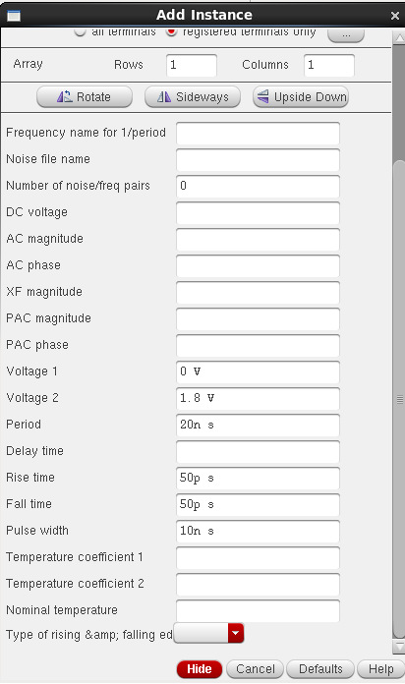 | 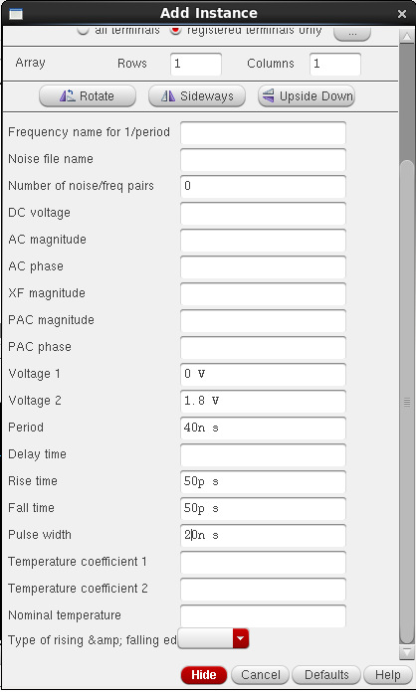
Figure-1.5. Add Instance window showing the pulse source V1 (NOR gate input A): Voltage 1 = 0 V, Voltage 2 = 1.8 V, period = 20 ns, pulse width = 10 ns. | Figure-1.6. Add Instance window showing the pulse source V2 (NOR gate input B): Voltage 1 = 0 V, Voltage 2 = 1.8 V, period = 40 ns, pulse width = 20 ns.
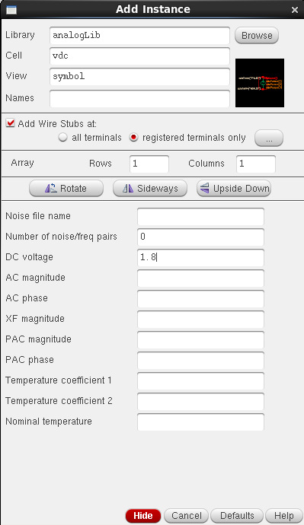
Figure-1.7. Add Instance window showing the vdc source used for the VDD supply, set to a DC voltage of 1.8 V.
1.4.6 Simulation Setup
The test bench was simulated in ADE L using the Spectre simulator, with the gpdk090 Spectre model library added under Setup → Model Libraries. A transient analysis was configured with a stop time of 200 ns so that several cycles of both the 20 ns-period input A and the 40 ns-period input B were captured. The input nets A and B and the output net Output were selected as the outputs to be plotted, and the simulation was run using Simulation → Netlist and Run.
1.4.7 Simulation Results: Input and Output Waveforms
Figure-1.8 shows the simulated transient response of the NOR gate. The left-hand plot shows the two pulse inputs, A (top) and B (bottom), each switching between 0 V and 1.8 V, with A having a 20 ns period and a 10 ns pulse width and B having a 40 ns period and a 20 ns pulse width, over a 60 ns window. The right-hand plot shows the corresponding output Vout (plotted as /Output) over a longer time axis that extends to about 90 ns. In every 40 ns period the two inputs step through (A, B) = (1, 1) from 0 to 10 ns, (0, 1) from 10 to 20 ns, (1, 0) from 20 to 30 ns and (0, 0) from 30 to 40 ns. Consistent with the NOR function, Vout is observed to be LOW (about 0 V) for the first three intervals and to go HIGH (about 1.8 V) only when both inputs are LOW, from 30 to 40 ns and again from 70 to 80 ns, in direct agreement with the two-input NOR truth table given in Table-1.1. At t = 0, when both inputs are still at their initial 0 V value, Vout starts at about 1.8 V, as expected for (A, B) = (0, 0), and then falls to 0 V as the inputs rise. The levels read from the waveforms are summarised in Table-1.3.
Time interval (ns) | A | B | Vout (observed)
0 – 10 | 1 | 1 | LOW (0)
10 – 20 | 0 | 1 | LOW (0)
20 – 30 | 1 | 0 | LOW (0)
30 – 40 | 0 | 0 | HIGH (1)
Table-1.3. Input and output levels read from the waveforms of Figure-1.8 for the first 40 ns period; the same four intervals repeat every 40 ns (for example, Vout is again HIGH from 70 to 80 ns).
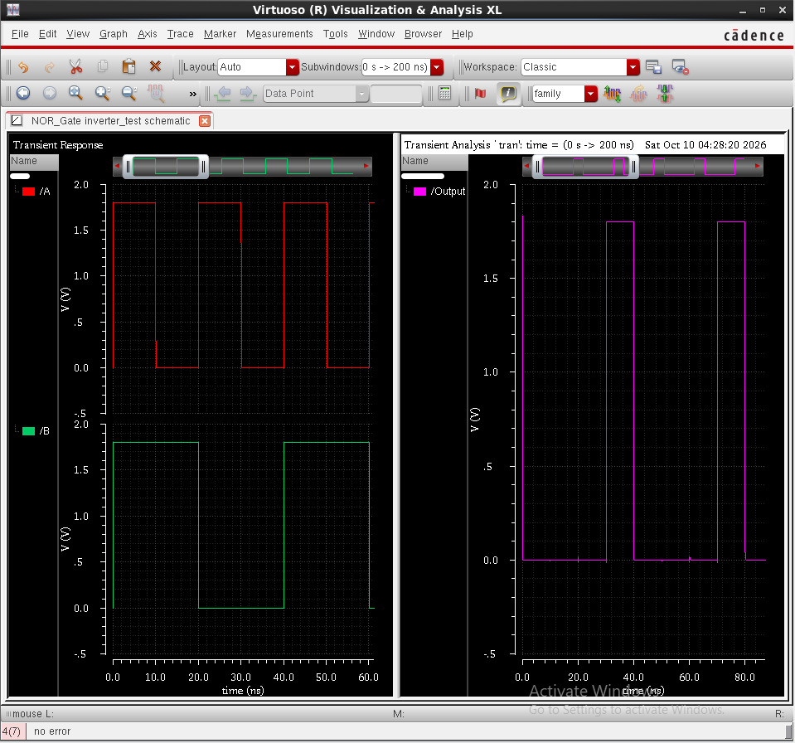
Figure-1.8. Simulation results: the two pulse inputs A and B (left) and the corresponding NOR output Vout, plotted as /Output (right, on a longer time axis than the inputs).
1.5 Discussion
The simulated behaviour of the designed circuit was found to be in agreement with the theoretical operation of a CMOS NOR gate described in Section 1.2. The transient simulation confirmed that the output Vout was HIGH only during the intervals where input A and input B were simultaneously LOW (30 to 40 ns and 70 to 80 ns in the observed window), and LOW otherwise, matching the expected truth table (Table-1.1). Because the pull-up and pull-down networks are never both fully ON for the same static input combination, the circuit is also expected to dissipate negligible static power, consistent with the fundamental advantage of CMOS logic. Retaining the same transistor dimensions used for the earlier CMOS inverter design (WP = 720 nm, WN = 240 nm, L = 100 nm) kept the design consistent with that experiment, although the series PMOS stack is expected to make the LOW-to-HIGH transition of the output somewhat slower than for a single-transistor pull-up; the stack did not, however, affect the correctness of the final logical output observed in simulation, and propagation delay was not measured in this experiment.
1.6 Conclusion
In this experiment, a two-input CMOS NOR gate was successfully designed at the transistor level in Cadence Virtuoso, using two series PMOS transistors as the pull-up network and two parallel NMOS transistors as the pull-down network from the gpdk090 technology library, and its schematic symbol was generated. A test bench was constructed with two independent pulse sources at the two inputs and a DC supply, and the circuit was verified through transient simulation using Spectre in ADE L. The observed input-output waveforms confirmed that the circuit correctly performs the logical NOR operation, producing a HIGH output only when both inputs were simultaneously LOW, consistent with the NOR truth table. This experiment provided practical, hands-on experience with the standard-cell schematic design flow for a two-input gate with a stacked pull-up network, which forms the basis for more complex digital and mixed-signal IC design in subsequent experiments.

